

“Factors Affecting and Determining
Wages in Palestine”

Supervised By DR : SAMEERA AWAWDA

Name Student : MOHAMMED ABU MARIA

Student ID : 1203411
Research Project Report
Table of Contents
Chapter 1: Introduction 1
1.1 Background of the Study 1
1.2 Problem Statement 3
1.3 Research Objectives 3
1.4 Research Questions 4
1.5 Significance of the Study 5
1.6 Scope and Limitations 6
1.7 Organization of the Report 7
Chapter 2: Theoretical Framework and Literature Review 9
2.1 Theoretical Framework 9
2.1.1 Theories of Wage Determination: 9
2.1.2 Economic Factors Influencing Wages 10
2.1.3 Labor Market Dynamics 11
2.2 Literature Review 12
2.3 Summary of Key Insights from the Literature 16
2.4 Methodological Approaches in Previous Studies 17
Chapter 3: Research Design and Methodology 19
3.1 Research Design 19
3.1.1 Econometric Model Selection 19
3.2 Data Sources 20
3.3 Study Variables 20
3.3 Data Analysis Techniques 21
Chapter 4: Empirical Results: 22
4.1 Descriptive Statistics 22
4.2 Regression Analysis 31
4.3 Discussion of Key Findings 34
Chapter 5: Conclusions and Recommendations 34
6.1 Summary of Findings 34
References 34

Chapter 1: Introduction

1.1 Background of the Study
Overview of Palestinian Economy
The Palestinian economy is characterized by a complex interplay between Palestinian national aspirations and the Zionist nationalist project, dating back to a century-old conflict. Within the historic territory of Palestine, two distinct economic models coexist: the globalized, industrialized Jewish economy of Israel and the Arab regional economies. However, today's Palestinian economy is fragmented, consisting of diverging peripheral Arab regions and enclave economies due to the challenging socio-political landscape in the region (Khalidi, 2017).
The Palestinian economy faces numerous challenges that significantly impact its performance. These challenges include political instability, limited access to resources, high unemployment rates, dependence on foreign aid, and weak institutional capacity.
The ongoing Israeli-Palestinian conflict and occupation create a highly unstable political environment in Palestine, which hinders economic growth and investment. Palestinians face restrictions on movement, trade, and access to natural resources due to the Israeli occupation, limiting their ability to develop industries and infrastructure. Unemployment is a significant issue, particularly among young people who struggle to find stable employment opportunities. The Palestinian economy relies heavily on international aid for development projects and basic services due to limited domestic revenue sources Inefficient governance structures and lack of transparency can hinder economic development efforts in Palestine (MAS,2023).
According to the latest report on the Performance of the Palestinian Economy for year 2023 (PCBS, 2024), economic indicators pointed out that:
In 2023, Palestine experienced a sharp GDP decline of 5.5% due to Israeli aggression beginning on October 7th, 2023. The Gaza Strip's economy collapsed, declining by 81.3% in the fourth quarter, which adversely affected the West Bank. The decline in international aid and unilateral deductions by Israel from clearance revenues exacerbated the fiscal crisis, impeding the government's ability to meet its financial commitments.
The aggression led to unprecedented unemployment levels, with the overall rate rising to 46.1%. The West Bank's unemployment rate reached 30%, while Gaza's soared to 75%. The labor force participation decreased to 44.1% from 45.4% in 2022, with variations between the West Bank (46.9%) and Gaza (40.1%).
The Palestinian government's current deficit surged by 478.2% in the fourth quarter of 2023 due to the Israeli aggression. The deficit reached USD 167.1 million, compared to USD 28.9 million in the previous quarter, driven by a sharp decline in economic activities and reduced public revenues.
The Israeli aggression and subsequent measures against Palestinian workers led to a 29.8% decline in compensation received by employees in Israel. This resulted in a 42.3% increase in the current account deficit, reaching USD 2,897.0 million, or 16.7% of GDP.
Palestine's total public debt increased by 6.8% to USD 3,782.3 million in 2023. Customer deposits in the banking sector grew by 6.8% to USD 17,589.0 million, while total credit facilities provided by the banking sector increased by 8.5% to USD 11,982.9 million.
The Consumer Price Index (CPI) in Palestine rose by 5.87% in 2023, primarily due to the Israeli aggression and recurrent raids. Major contributing factors included food, non-alcoholic beverages, transportation, housing, and utilities.
Palestinian labor market
As for the Palestinian labor market (World Bank, 2022), it is characterized by low participation rates and high unemployment, exacerbated by significant gender and regional disparities. As of the end of 2022, only 45% of the labor force was active, and unemployment stood at 23.4%. The gender gap is substantial, with women's labor force participation remarkably low, often due to cultural roles categorized as "housekeeping”. From 2000 to 2021, the labor force grew by about 35,000 workers annually, but the economy only created around 20,200 jobs per year, leading to rising unemployment rates, which climbed from 14.3% in 2000 to 26.4% in 2021. This issue is more acute in Gaza, where unemployment reached 47% in 2021 compared to 15.5% in the West Bank. Youth and women are particularly affected, with youth unemployment in Gaza surpassing 60%. Women face wage disparities and lower entrepreneurship rates despite higher educational achievements. Most employed women work in service sectors like education, public administration, and health. The growth-employment elasticity in Palestine is relatively high, suggesting that boosting economic growth can significantly impact employment. At the end, while policy reforms are necessary, easing restrictions on movement, investment, and trade imposed by the Israeli occupation is crucial for substantial labor market improvements.
Wage in Palestine
The average monthly wage in Palestine varies depending on the region and sector. In general, wages tend to be lower in Gaza compared to the West Bank. It's important to note that there are significant disparities between different industries and professions within Palestine. For example, professionals such as doctors or engineers may earn significantly higher salaries than workers in other sectors like agriculture or construction. Additionally, economic conditions and political instability can also impact wages in Palestine. Unemployment rates are high, which can put downward pressure on wages for many workers. Overall, while some individuals may earn relatively high salaries by Palestinian standards, many others struggle with low incomes and limited job opportunities.
Wage determination is a critical aspect of labor economics, influencing the standard of living, income distribution, and economic development of a country. In Palestine, understanding the factors that affect and determine wages is essential for policymakers, employers, and workers to make informed decisions. This research aims to explore and analyze the key factors influencing wage levels in Palestine.

1.2 Problem Statement
In Palestine, the complexity of the economic environment, characterized by political instability, occupation, and economic restrictions, poses significant challenges to the labor market and wage dynamics. Understanding the factors that affect and determine wages in such a context is essential for policymakers, employers, and workers to make informed decisions and implement effective strategies.
Despite various studies on wage determination globally and regionally, there is a gap in the literature specifically addressing the unique economic and political conditions in Palestine. The Palestinian labor market is marked by high unemployment rates, significant regional disparities between the West Bank and Gaza Strip, a large informal economy, and pronounced gender disparities (PCBS, 2023). These factors, compounded by the impact of Israeli occupation and internal political divisions, create a distinctive environment that requires tailored analysis.
The primary problem this research seeks to address is the lack of comprehensive understanding of the key factors influencing wage levels in Palestine. By investigating the determinants of wages, this study aims to provide insights into how economic conditions, and labor market dynamics affect wage levels in Palestine. This understanding is crucial for developing effective policies and interventions to improve labor market outcomes, enhance economic stability, and promote equitable income distribution in the Palestinian context.

1.3 Research Objectives
Main objective:
The main objective of the study is to identify key factors influencing wage determination in Palestine.
Specific objectives:
The specific objectives are:
- To examine the effect of gender, occupation, and industry activity on wages levels.
- To assess the influence of economic conditions and labor market trends on wages.

1.4 Research Questions
To guide the investigation and achieve the research objectives, the study will address the following research questions:
To examine the effect of gender, occupation, and industry activity on wage levels.
Research Question 1: How does gender influence wage levels in Palestine?
- Sub-question: What is the wage gap between males and females across different sectors?
Research Question 2: How do different occupations affect wage levels in Palestine?
- Sub-question: What are the wage variations among high-skill, medium-skill, and low-skill occupations?
Research Question 3: What is the impact of industry activity on wage levels in Palestine?
- Sub-question: How do wages differ across various industries such as manufacturing, services, and agriculture?
To assess the influence of economic conditions and labor market trends on wages.
Research Question 4: How do economic conditions (inflation, GDP growth) affect wage levels in Palestine?
- Sub-question: What is the relationship between macroeconomic indicators and wage trends over the past decade?
Research Question 5: What is the impact of labor market trends (unemployment rates, labor force participation) on wage levels in Palestine?
- Sub-question: How do changes in labor market dynamics influence wage structures and employment conditions?

1.5 Significance of the Study
This research on the factors affecting and determining wages in Palestine holds significant importance for various stakeholders, including policymakers, employers, workers, and academic researchers. The study's significance can be highlighted through the following points:
- Policy Formulation and Implementation:
- Informed Decision-Making: The findings of this study will provide policymakers with empirical evidence and analytical insights needed to design effective labor market policies. Understanding the key factors influencing wages will help in developing targeted interventions to address wage disparities, reduce unemployment, and promote equitable income distribution.
- Economic Development: By identifying the economic and political constraints affecting wage determination, the study will offer policy recommendations that can enhance economic stability and growth in Palestine. Strategic investments and supportive policies can be formulated to boost sectors with high growth potential, thereby creating more job opportunities and improving wage levels.
- Employer Strategies:
- Improved Wage Structures: Employers can benefit from understanding the determinants of wages in Palestine. This knowledge will enable them to design fair and competitive wage structures that reflect the economic conditions and labor market dynamics. Aligning wages with productivity and skills can improve employee satisfaction and retention.
- Sectoral Insights: The study’s sector-specific analysis of wage levels will help employers in different industries to benchmark their compensation practices against the broader market, ensuring they remain competitive and attract skilled talent.
- Worker Empowerment:
- Labor Market Navigation: Workers will gain valuable insights into the factors influencing wages in Palestine, helping them make informed career decisions. Understanding the impact of skills, education, and experience on wage levels can guide individuals in their professional development and job search strategies.
- Advocacy and Negotiation: The study’s findings can empower workers and labor unions in advocating for better wages and working conditions. Knowledge of wage determinants will strengthen their position in negotiations with employers and policymakers.
- Academic Contribution:
- Filling Research Gaps: This study addresses the gap in the literature regarding wage determination in the unique economic and political context of Palestine. It contributes to the broader field of labor economics by providing empirical evidence and theoretical insights specific to conflict-affected regions.
- Foundation for Future Research: The research findings will serve as a foundation for future studies on labor markets in similar contexts. It will open avenues for further exploration into the impact of political instability, economic restrictions, and regional disparities on labor market outcomes.

1.6 Scope and Limitations
Scope of the Study
- Geographical Scope:
- The study focuses on the Palestinian territories, including both the West Bank and Gaza Strip. It examines the regional differences in economic conditions, labor market dynamics, and wage levels within these areas.
- Temporal Scope:
- The research utilizes secondary data sources covering recent years to provide a current and relevant analysis of wage determination. Historical data may also be referenced to contextualize trends and changes over time.
- Thematic Scope:
- The study investigates various factors affecting wage determination, including economic conditions (GDP, inflation), and labor market dynamics (unemployment, labor force participation).
- It also explores sector-specific wage levels and trends, examining how different industries within Palestine are impacted by the identified factors.
Limitations of the Study
- Data Availability and Reliability:
- The study relies on secondary data, which may have limitations in terms of availability, accuracy, and comprehensiveness. Data gaps or inconsistencies can affect the robustness of the analysis and the validity of the conclusions.
- Some data sources may not be up-to-date, reflecting past rather than current conditions, which could impact the relevance of the findings.
- Complex Political Context:
- The unique political situation in Palestine, including the ongoing Israeli occupation and internal political divisions, introduces complexities that may not be fully captured through quantitative analysis alone. Qualitative insights might be necessary to understand the full impact of political factors on wage determination.
- Economic Volatility:
- The Palestinian economy is subject to significant volatility due to political instability, external shocks, and economic sanctions. This volatility can lead to rapid changes in economic conditions that may not be fully reflected in the data, limiting the study’s ability to predict future trends.
- Scope of Factors Analyzed:
- The study focuses on key economic, political, and labor market factors but may not capture all potential determinants of wages, such as cultural and social factors, informal networks, or external influences (international aid policies for example).
- Comparative Analysis Limitations:
- Comparing wage determination mechanisms in Palestine with those in neighboring countries or similar regions may be challenging due to differences in political, economic, and social contexts. These comparisons should be interpreted with caution.
- Generalizability of Findings:
- The unique context of Palestine means that findings may not be easily generalizable to other regions. The specific economic, political, and social conditions in Palestine create a distinct environment for wage determination.

1.7 Organization of the Report
The research report on "Factors Affecting and Determining Wages in Palestine" will be organized into the following chapters:
Chapter 1: Introduction
Chapter 2: Theoretical Framework and Literature Review
Chapter 3: Research Design and Methodology
Chapter 4: Empirical Results
Chapter 5: Conclusions and Recommendations
References
Appendices
- Appendix A: Data Tables

Chapter 2: Theoretical Framework and Literature Review

2.1 Theoretical Framework

2.1.1 Theories of Wage Determination:
In examining the factors that affect and determine wages in Palestine, it is crucial to explore various theoretical frameworks that have been developed to understand wage determination. The following sections outline key theories and concepts relevant to this study:

2.1.1.1 Human Capital Theory
Human Capital Theory posits that wages are determined by the skills, knowledge, and experience that workers bring to their jobs. According to this theory, investments in education and training enhance workers' productivity, which in turn leads to higher wages. Gary Becker (1964), a prominent advocate of this theory, argues that individuals and firms invest in human capital to increase productivity and earnings potential. This theory suggests that disparities in wages can be explained by differences in education, experience, and other forms of human capital (Mincer,1974).

2.1.1.2 Labor Market Segmentation Theory
Labor Market Segmentation Theory argues that the labor market is divided into distinct segments or sectors, each with its own wage-setting mechanisms and employment conditions. This theory contrasts with the neoclassical view of a unified labor market. Piore (1972) and Doeringer & Piore (1971) emphasize the existence of primary and secondary labor markets. The primary labor market is characterized by stable, well-paying jobs with good working conditions, while the secondary labor market consists of low-paying, unstable jobs with poor working conditions. This segmentation can result from institutional factors, discrimination, and barriers to mobility between segments.

2.1.1.3 Gender Wage Gap
The Gender Wage Gap theory examines the differences in wages between men and women. This theory attributes wage disparities to a combination of factors, including discrimination, occupational segregation, and differences in human capital. Blau & Kahn (2000) highlight that even after controlling for education, experience, and occupation, a significant portion of the wage gap remains unexplained, suggesting the presence of discrimination. Gender norms and societal expectations also play a role in shaping career choices and opportunities for men and women, further contributing to wage disparities (Goldin, 2014).
These theories provide a framework for analyzing wage determination in Palestine. By applying these theoretical perspectives, this study aims to uncover the multifaceted factors that influence wages and contribute to the understanding of wage dynamics in the context of the Palestinian economy.

2.1.2 Economic Factors Influencing Wages
The determination of wages is influenced by various economic factors, including GDP growth and inflation. These factors are critical in understanding wage dynamics within the Palestinian economy.

2.1.2.1 GDP Growth
Gross Domestic Product (GDP) growth is a key indicator of economic health and a significant factor influencing wage levels. Higher GDP growth typically signals increased economic activity and productivity, which can lead to higher demand for labor and subsequently higher wages. Conversely, stagnant or negative GDP growth can result in reduced labor demand and wage stagnation or decline.
Economic Expansion: During periods of economic expansion, businesses experience increased profits and productivity, allowing them to raise wages to attract and retain skilled workers (Solow, 1956).
Labor Demand: Higher GDP growth often leads to higher labor demand, reducing unemployment rates and increasing bargaining power for workers, which can lead to higher wages (Mankiw, 2009).
In the Palestinian context, GDP growth is heavily influenced by political and economic instability. For instance, the economic impact of the Israeli occupation, restrictions on movement, and frequent conflicts significantly hinder consistent GDP growth, which in turn affects wage levels (World Bank, 2018).

2.1.2.2 Inflation
Inflation is the rate at which the general level of prices for goods and services rises, eroding purchasing power. It has a direct impact on real wages, which are wages adjusted for inflation.
-Erosion of Purchasing Power: High inflation reduces the purchasing power of wages, meaning workers need higher nominal wages to maintain their standard of living (Friedman, 1968).
- Wage-Price Spiral: In some cases, rising inflation can lead to higher wage demands, as workers seek to maintain their real incomes. This can create a wage-price spiral, where wages and prices continuously push each other higher (Phillips, 1958).
In Palestine, inflation is influenced by external factors, such as fluctuations in global commodity prices and economic policies. The ongoing conflict and political instability also contribute to economic disruptions, which can cause inflationary pressures, further complicating wage determination (Palestinian Central Bureau of Statistics, 2023).

2.1.3 Labor Market Dynamics
Labor market dynamics, including employment and unemployment rates and labor force participation, are critical components in understanding wage determination. These factors provide insight into the availability of labor, the level of economic activity, and the overall health of the economy.

2.1.3.1 Employment and Unemployment Rates
Employment and unemployment rates are key indicators of labor market health and economic performance:
Employment Rate: The employment rate measures the proportion of the working-age population that is employed. Higher employment rates generally indicate a robust economy with ample job opportunities, which can exert upward pressure on wages as employers compete for workers.
Unemployment Rate: The unemployment rate represents the percentage of the labor force that is actively seeking employment but unable to find work. High unemployment rates often signal economic distress and can suppress wage growth due to an oversupply of labor. Conversely, low unemployment rates typically lead to increased wage pressures as labor becomes scarce.
In Palestine, unemployment rates are significantly high due to a combination of political instability, restricted access to resources, and limited economic opportunities. According to the Palestinian Central Bureau of Statistics (PCBS), the unemployment rate in the 3rd quarter of 2023 was about 24%, with female unemployment rates even higher “was about %41” (PCBS, 2023).

2.1.3.2 Labor Force Participation
Labor force participation refers to the percentage of the working-age population that is either employed or actively seeking employment. Several factors influence labor force participation:
Economic Conditions: Strong economic conditions encourage higher labor force participation as job opportunities become more abundant. Conversely, economic downturns can discourage job seekers, leading to lower participation rates.
Social and Cultural Factors: In many societies, social and cultural norms influence who participates in the labor force. In Palestine, cultural expectations regarding gender roles significantly impact female labor force participation.
Educational Attainment: Higher levels of education generally lead to higher labor force participation rates, as educated individuals are more likely to seek and find employment.
This analysis of labor market dynamics provides a foundation for exploring the specific factors influencing wages in the Palestinian economy. In Palestine, labor force participation is affected by a range of economic, social, and cultural factors. The overall labor force participation rate in Palestine was around 44.4% in the 3rd quarter of 2023, with notable differences between the West Bank (47.3%) and Gaza Strip (39.8%) (PCBS, 2023).

2.2 Literature Review
Many studies have explored how wages are decided, the theory of human capital, how the job market is divided, the difference in pay between genders, and how economic factors affect wages. Here, we will discuss some of the relevant literature on these topics.
One study by the International Monetary Fund in 1999 looked at the Palestinian job market after the Oslo Accords. It found that unemployment went up a lot because there weren't many new jobs in private companies, and people relied too much on jobs in Israel and settlements. The reasons for this high unemployment included having a lot of young people who weren't working, not enough social safety nets, and not enough jobs available. This study showed how these problems affected families. It also talked about how economic policies affected job opportunities (International Monetary Fund, 1999).
A recent report by the International Monetary Fund (Coulibaly, Ma, & Qassis, 2023)confirmed ongoing problems and complications in the Palestinian labor market. It showed that labor market in the West Bank and Gaza, is still grappling with challenges such as low labor force participation, high unemployment rates, and disparities in employment rates and wages between the two regions. The report said it's important for policies to help with these problems by improving how the job market is managed, making technical education better, getting more women to work, creating more jobs, and making workers more productive. In addition, this report explained that, easing restrictions on movement and enhancing donor coordination could further contribute to improving labor market outcomes in the region.
Another study by the Palestine Economic Policy Research Institute in 2006 (Naqib, 2006) looked at wages and productivity in Palestinian industries from 1996 to 2004. It found that wages went down while productivity went up a little. Some reasons for low productivity were that there wasn't enough investment in resources and some things were done inefficiently. The study suggested ways to make industries more competitive, like dealing with issues caused by the Israeli occupation, helping these industries financially, and connecting relief projects to industry growth.
Another study in 2007 talked about the differences in pay between jobs in the public sector, private sector, and non-governmental organizations (NGOs) (Mataria, 2007). It found that NGOs paid the most, then the private sector, and then the public sector. This study also looked at how things like age, education, job type, and where you work can affect how much you get paid. It suggested better management of resources, paying people based on how well they perform at work, and improving services by private companies and NGOs.
A study in 2010 showed that just setting a minimum wage for low-skilled workers in Palestinian businesses might not work well. This is because if wages go up too much, businesses might hire fewer workers and produce less. Instead, the study suggested giving money to businesses that have to pay the minimum wage. This would help them pay these higher costs without causing problems for other local businesses(مساليا، كابيلي، و عامر، 2010).
Another study in 2014 looked at why people get paid differently in different industries in places like the West Bank and Gaza (Adnan, 2014). It found that factors like how good the workers are, how the job market is divided between public and private jobs, and how people act at work affect how much they get paid.
Another study (Yousef & Belal, 2014) in 2014 looked at why people in cities get paid differently from people in the countryside in Palestine. This study also talked about how the conflict between Palestine and Israel affects wages, especially in places like Area C. The study showed that giving money for education and helping people get better at their jobs could help reduce pay differences between cities and rural areas.
The minimum wage is important for fairness and helping workers. In 2012, Palestine set its minimum wage, but many workers still earn less. In 2014, a study conducted in the West Bank to analyze the demographic, geographic, and economic characteristics of workers earning below the minimum wage, and to explore the implementation and compliance with the national minimum wage set for Palestinian workers. It found that 23% of all waged workers earned below the minimum wage, with higher rates in the private sector and among females, less educated individuals, and younger workers. The study suggests ways to make sure employers follow the minimum wage rules better, like more inspections and higher fines for not paying enough(Al-Falah, 2014).
According to other study looked at how much workers in Area C of the West Bank get paid compared to workers in other places (Fallah & Daoud, 2015), it found that at first, workers in Area C get paid less, but this changes when we consider things like their skills and traits. To reduce wage gaps between cities and rural areas, it's suggested to support education and skills training. The study also shows that the wage difference in Area C is more about it being rural than about Israeli economic rules. Commuting can help balance out bad changes in the job market. Worker traits explain about 30% of the wage gap between Area C and other places. Some of this can be explained by skills, while some can't be easily explained. Overall, the study suggests that the rural environment has a bigger impact on wages in Area C than Israeli rules do.
As for the difference in wages between the public and private sectors in the Palestinian labor market, a study examined this difference before and during the "second Intifada" using data from the Palestinian Labor Force Survey (Hiaari, 2020). The study breaks down the wage difference into two parts: one related to what skills people have, and one related to how much they get paid for those skills. It found that before the Intifada, the wage gap was getting smaller, but during and after it, it grew a lot. This was mainly because the public sector started paying more for certain skills. Also,it found that the public sector pays better at lower income levels but not as well at higher ones. The study suggests that the public sector's attractiveness to workers, coupled with economic challenges, may have influenced employment trends and political strategies in the region.
The differences in employment choices and wages between the private and public sectors in Palestine, focusing on gender was the subject of another paper by Yousef Daoud from Birzeit University and Ruba Shanti from the World Food Programme (Daoud & Shanti, 2016). The results showed big differences between men and women in job choice, pay based on education, and why there are pay gaps between job types and genders. Education doesn't always lead to higher pay for both men and women, especially in jobs where education isn't valued much. It found that in the public sector, women are predicted to earn more than men. In other sectors like private jobs, the results were mixed. This is because the public and "other" sectors tend to have higher pay compared to private jobs, mainly because people with lower education levels often end up in private jobs. The study also found that as people gain more experience, they are more likely to choose better-paying jobs, but this effect is stronger for men than for women. Education helps both men and women get into better-paying jobs, but for men, it's true for all sectors, while for women, it's mainly true for public and "other" sectors, not so much for private jobs. Where people live also affects the jobs they choose. For example, men in the West Bank are more likely to work in private jobs compared to those in Gaza. For women, it's different; they are more likely to work in public jobs in the West Bank than in Gaza. This shows that where you live can influence the types of jobs available and the ones you choose. Also, it found that women tend to earn more than men for most levels of education. However, these changes depending on the job sector and over time. In the public sector, women are predicted to earn more, but in private jobs, the results are mixed and not consistent over time.Overall, this study shows that there are big differences in job choices, pay based on education, and pay gaps between job types and genders. It also highlights how where you live and your marital status can affect the jobs you choose and how much you earn.
The results of another paper (Ayyash & Kun, 2019) that explored wage differentials, labor force participation, and income inequality in Palestine, highlighted significant wage disparities between different occupations and emphasized the role of factors such as education, age, region, gender, marital status, locality, sector, industry, place of work, and work contract significantly contribute to wage inequality among workers in Palestine.
As for the COVID-19 pandemic, an assessment (Al Botmeh & Sadeq, 2020)looked at how COVID-19 affected things like job loss, changes at work, and the economy in Palestine in September 2020. It found that COVID-19 caused big problems in the job market there, leading to fewer jobs, shorter work hours, and challenges for people working in informal jobs. Industries like manufacturing, transport, and construction were hit hard by supply problems. The government tried to help by supporting key industries and workers who lost jobs, and by boosting the economy. Workers in informal jobs were hit hardest. They couldn't go to work or work from home, so they lost income. Unlike some workers, they didn't get help from an agreement to pay part of their wages during the crisis. COVID-19 also affected wages differently in different industries. Some, like telecommunications, were expected to see higher wages, but others, like mining and construction, were expected to see lower wages.
From gender base prospective, a study in 2022 looked at how men and women are treated differently in the job market in Palestine(MORRAR, 2022). It found that women often don't work as much because of cultural and job requirements, which leads to them getting paid less than men even if they have the same education. This study showed how women face discrimination in many sectors of the job market. It also talked about how things like cultural norms, not enough job options, and the Palestine-Israel conflict affect women's pay. The study suggested ways to fix these problems and make sure men and women get treated fairly at work.
The IMF (Coulibaly, Ma, & Qassis, 2023)confirmed that women in the Palestinian labor market face persistent gender wage gaps, with women's average daily wage being about a third lower than their male colleagues in nearly all sectors. This wage disparity discourages women from seeking employment and contributes to the overall challenges faced by women in the labor market.

2.3 Summary of Key Insights from the Literature
The literature on wage determination encompasses a range of studies that shed light on various factors influencing wages. Key insights from the review can be grouped into several categories: Human Capital Theory, Labor Market Segmentation, Gender Wage Gap, and Economic Factors such as GDP growth, inflation, and labor market conditions.
Human Capital Theory
Human Capital Theory posits that investments in education, training, and skills development enhance an individual's productivity, leading to higher wages. This theory is particularly relevant in the Palestinian context, where educational attainment and vocational training are critical for improving labor market outcomes. The IMF's 1999 study and subsequent reports highlight the need for policies that enhance technical education and skills training to address high unemployment and improve labor productivity.
Labor Market Segmentation
Labor Market Segmentation Theory suggests that the labor market is divided into distinct segments with varying wage levels and employment conditions. This division often results in wage disparities and affects worker mobility. Studies by Mataria (2007) and Adnan (2014) illustrate how wages differ across sectors (public, private, NGOs) and regions (West Bank, Gaza), highlighting the importance of addressing these disparities through targeted policies.
Gender Wage Gap
The Gender Wage Gap remains a significant issue in the Palestinian labor market, with women consistently earning less than men. Factors contributing to this gap include occupational segregation, discrimination, and cultural norms. The studies by Al-Falah (2014), Daoud & Shanti (2016), and Morrar (2022) emphasize the need for policies that promote gender equality, such as better enforcement of minimum wage laws, enhancing women's access to education and employment opportunities, and addressing cultural barriers.
Economic Factors
Several economic factors play a crucial role in determining wages in Palestine:
- GDP Growth: Economic growth can lead to increased demand for labor and higher wages. However, the Palestinian economy faces significant challenges, including political instability and movement restrictions, which hinder growth.
- Inflation: Inflation affects the real purchasing power of wages. High inflation can erode real wages, making it crucial to manage inflation effectively to protect workers' living standards.
- Labor Market Conditions: High unemployment rates and low labor force participation are persistent issues in Palestine. Studies indicate that improving labor market management, creating more job opportunities, and increasing productivity are essential for addressing these challenges.
In addition, studies provide detailed insights into the unique factors affecting wage determination in Palestine, these factors include:
- Impact of Occupation and Restrictions: The Israeli occupation and movement restrictions significantly impact wage levels and employment opportunities. Studies by Naqib (2006) and Fallah & Daoud (2015) document how these restrictions limit economic activities and suppress wage growth.
- Sectoral Wage Differences: Wages vary significantly across different sectors. NGO jobs tend to pay more than private sector jobs, which in turn pay more than public sector jobs. This segmentation suggests the need for better resource management and performance-based pay systems.
- Rural vs. Urban Wage Disparities: Wages differ between rural and urban areas, influenced by factors such as the availability of job opportunities, education levels, and the impact of conflict. Policies supporting education and skills training in rural areas can help reduce these disparities.
- Minimum Wage Compliance: Despite the establishment of a minimum wage, compliance remains an issue, particularly in the private sector and among vulnerable groups such as women and young workers. Enhanced inspections and stricter penalties for non-compliance are necessary to ensure fair wages for all workers.

2.4 Methodological Approaches in Previous Studies
The literature employs various methodological approaches to analyze wage determinants, including:
- Econometric Analysis: Regression models are commonly used to estimate the impact of different factors on wages, allowing for a quantitative assessment of wage determinants.
- Qualitative Research: Interviews and case studies provide in-depth insights into the experiences of workers and employers, capturing the nuances of wage dynamics.
- Survey Data: Large-scale surveys such as labor force surveys and household income surveys offer comprehensive data for analyzing wage patterns across different demographics and regions.
- Comparative Studies: Examining wage determinants across different countries or regions helps identify common patterns and unique factors affecting wages, providing a broader perspective on wage dynamics.
The theoretical model for determining wages (average monthly wages) in Palestine can be constructed based on Human Capital Theory.
Human Capital Theory suggests that individuals invest in their own education and training to improve their productivity, which in turn increases their potential earnings. The model can also incorporate industry and occupation as determinants of wages. This theory was extensively developed by economists such as Gary S. Becker (Becker, G. S.,1964) and Jacob Mincer (Mincer, J.,1974).
A suitable theoretical model for examining the factors affecting wages is the Mincer Earnings Function (Mincer, J.,1974). This model posits that an individual's wage is determined by their human capital, which includes education and experience. The Mincer equation can be extended to incorporate additional factors like gender, industry, occupation, and other demographic and employment characteristics.
The basic Mincer Earnings Function is:
Log (Wage) = β₀ + β₁ (Education) + β₂ (Experience) + β₃ (Experience²) + ϵ
Where:
- Log (Wages) is the natural logarithm of wages.
- Education is the number of years of schooling.
- Experience is the number of years of work experience.
- Experience2 is the square of the number of years of work experience to capture the nonlinear relationship between experience and wages.
- Epsilon (ϵ) is the error term.

Chapter 3: Research Design and Methodology
This chapter provides a detailed outline of the procedures and strategies employed in the study to investigate the factors affecting and determining average monthly wages in Palestine. Key section included in this chapter are: Research Design, Data Sources, Data Analysis Techniques, Validity and Reliability, and Ethical Considerations.

3.1 Research Design

3.1.1 Econometric Model Selection
  - Selection Criteria
When selecting an econometric model for this study, the following criteria were considered:
- Nature of the Dependent Variable: The econometric model should be selected based on the nature of the dependent variable and the research questions. Given that wages are continuous, OLS regression is appropriate.
- Distribution of the Data: The distribution of wages and the potential for non-linear relationships between the independent variables and wages.
- Theoretical Justification: The theoretical model remains rooted in the Mincer Earnings Function, but with a focus on how employment characteristics (e.g., education, gender, age) impact average wages rather than a direct assessment of wages. The core idea is still that human capital (education, experience) and demographic factors influence wages.
  - Proposed Model
- The proposed model will include variables from different categories to capture their effects on wages:
- Log (Wages)=β₀ + β₁ (Gender) + β₂ (Age) + β₃ (Education)+ β₄ (Sector)+ β₅ (Occupation) +
β₆ (Activity) + β₇ (Unemployment) + β₈ (GDP) + β₉ (CPI) + β₁₀ (Year) + ϵ
Where:
- Wages​ = Average monthly wages in years of the study
- Gender​ = Employment by sex in years of the study
- Age ​ = Employment by age group in years of the study
- Education ​ = Employment by different education levels in years of the study
- Sector​ = Employment by economic sector (private or public) in years of the study
- Occupation​ = Employment by occupation in years of the study
- Activity​ = Employment by economic activity (industry) in years of the study
- Unemployment​ = Unemployment rate in year of the study
- GDP ​ = GDP in USD millions in year of the study
- CPI ​ = Consumer Price Index in year of the study
- Year ​ = year of the study
- ϵ (epsilon)​ = Error term

3.2 Data Sources
- Secondary Data Sources:
This study used data from:
- Palestinian Labor Force Surveys (LFSs) conducted by PCBS covering the years 2015-2022.
- ILO online data published set.
The data sourced from both PCBS and ILO publications and on their dataset websites. The survey data includes detailed information on individual and workplace characteristics, allowing for a comprehensive analysis of wage determinants. Then it was prepared for the purposes of the present study. The study's population consists of all waged adult individuals working in the public and private sectors of Palestine. This excludes workers in Israel and in settlements, self-employed individuals and those performing unpaid activities. The analysis is restricted to individuals aged 15 to 65 years old, and excludes individuals with missing or unknown wage information. Collected data is attached in annex 01.

3.3 Study Variables
The dependent variable is the Average monthly wages in Palestine. Several recodes of the set of independent variables were held to guarantee appropriate inter-group comparisons. The next Table presents a description of the dependent and the list of independent variables used in the analyses:
Variable | Description
Average monthly wages | The dependent variable: Monthly wage of employed workers expressed in fixed amount by years 2015 to 2022. Collected amounts are in NIS.
Year | Years of the study and related data :2015-2022
Employment by Gender | The employment by gender of the workers according to their sex (M,F).
Employment by Age | Represent number of employed workers according to their age, it is grouped into six categories: (15-24,25-34,35-44,45-54,55-64, and 65+)
Employment by Education | Represent the number of employments by education level for workers.
Employment by Institutional Sector | Represent number of employed workers according to their sector of work: Public or Private.
Employment by Occupations | Represent number of employed workers according to their type of profession.
Employment by Economic Sector Activity | Represent number of employed workers according to their economic sector activity.
Unemployment | The amount of unemployment for the study years.
GDP | Gross Domestic Product (GDP) IN USD Millions (at constant prices: 2015).
CPI | Consumer price index as indicator of inflation.

3.3 Data Analysis Techniques
An Ordinary Least Squares (OLS) regression model is employed to analyze the relationship between wage and the independent variables. This method is chosen based on the nature of the dependent variable and the research questions.
The analysis will be conducted using statistical software SPSS. The steps include:
Data Cleaning and Preparation: Recoding variables to ensure appropriate inter-group comparisons and transforming the daily wage variable as the dependent variable.
Model Estimation: Fitting the (OLS) regression model to the data.
Diagnostic Tests: Checking the proportional odds assumption and other model diagnostics to ensure the model's validity.
Interpretation: Analyzing the estimated coefficients to understand the impact of each variable on wage.
By following this research design, the study aims to provide a comprehensive analysis of wage determinants in the Palestinian labor market, leveraging both theoretical insights and robust econometric methods.

Chapter 4: Empirical Results:

4.1 Descriptive Statistics

- Average Monthly Earnings by Sex 2015-2022 in Palestine
The average monthly earnings for both males and females have shown an upward trend from 2015 to 2022. Males consistently earned higher than females throughout the years, reflecting an ongoing gender wage gap.

Gender Wage Gap: In 2015, the average monthly earnings for males were 2,342.03 NIS, whereas for females, it was 1,810.68NIS, indicating an initial wage gap.The wage gap continued to persist in subsequent years, with males earning higher than females in every year analyzed.By 2022, the average monthly earnings for males reached 3,214.54NIS, while for females, it was 2,288.27NIS, highlighting a significant gender wage disparity despite the overall increase in earnings for both genders.
Annual Growth Rates: The annual growth rate of average monthly earnings for males ranged from approximately 2% to 8% during the period with a growth rate average 4.64% over all the period, showing a relatively steady increase.For females, the annual growth rates were slightly higher, fluctuating between -6% and 11%with a growth rate average 3.54% over all the period, indicating a faster but still insufficient growth compared to males.
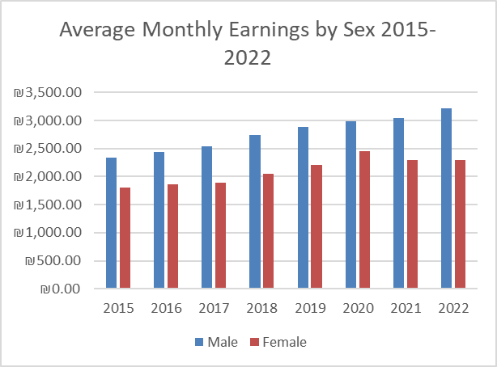

Gender Wage Ratio: The gender wage ratio, calculated as the ratio of average monthly earnings for males to females, ranged from approximately 1.29 to 1.41 during the years 2015-2022.This ratio signifies that, on average, males earned around 31.67% more than females across the analyzed period.

The statistical analysis of Average Monthly Earnings by Sex from 2015 to 2022 in Palestine highlights a persistent gender wage gap, with males consistently earning higher than females. Although both genders experienced an increase in earnings over time, the gap remains significant, indicating the need for continued efforts to address gender-based wage disparities and promote equitable pay practices in the labor market.

- Average Monthly Earnings by Activities 2015-2022 in Palestine

The data indicates a general growth trend in average monthly earnings across different economic activities in Palestine from 2015 to 2022 that reflects improvements in various sectors.
Trends Over Time: Average monthly earnings in agriculture have shown a slight increase over the years, from 1,644.29 NIS in 2015 to 2,092.32 NIS in 2022.Earnings in the construction sector have also increased steadily, from 3,486.03 NIS in 2015 to 4,997.80 NIS in 2022.The manufacturing sector witnessed moderate growth, with earnings rising from 1,894.64 NIS in 2015 to 2,754.66 NIS in 2022.Earnings in the Mining and Quarrying; Electricity, Gas and Water Supplysector fluctuated but generally increased, reaching 2,693.69 NIS in 2022 from 2,249.80 NIS in 2015.Public Administration, Community, Social and Other Services and Activitiessector showed consistent growth in earnings, from 2,150.82 NIS in 2015 to 2,619.93 NIS in 2022.Trade, Earnings in the Transportation, Accommodation and Food, and Business and Administrative Services sector rose steadily from 1,726.13 NIS in 2015 to 2,337.21 NIS in 2022.
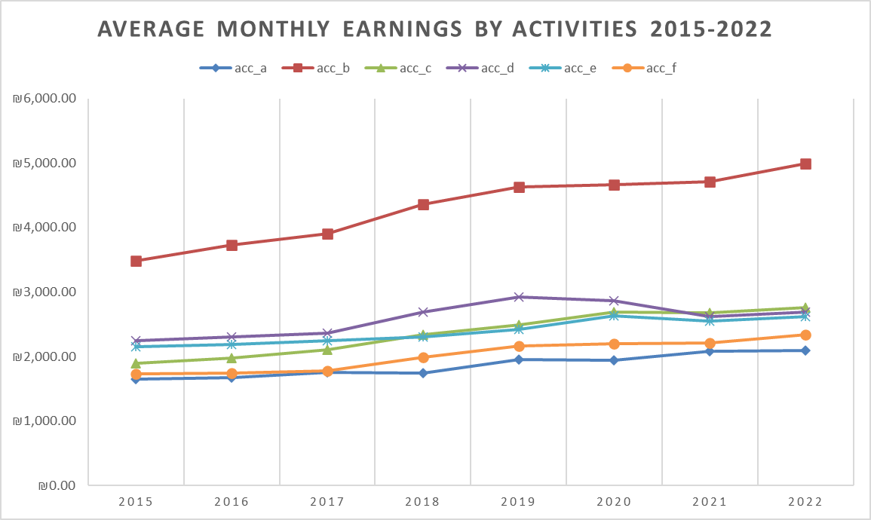
Sectoral Comparisons: The construction sector consistently recorded the highest average monthly earnings across the years, followed by the Public Administration, Community, Social and Other Services and Activities sector.Manufacturing and Mining and Quarrying; Electricity, Gas and Water Supply sectors reported moderate earnings growth.Agriculture consistently had lower average monthly earnings compared to other sectors, although it showed some growth over time.
Stability and Growth: Overall, most sectors experienced stable growth in average monthly earnings over the years.

- Average Monthly Earnings by Occupations 2015-2022 in Palestine

Overall Trends: Across all occupations, there is a general upward trend in average monthly earnings from 2015 to 2022, indicating an overall improvement in income levels in Palestine.
Managers consistently have the highest average monthly earnings throughout the years, followed by professionals and technicians.While some occupations experienced steady growth in earnings, others showed stability with minor variations.
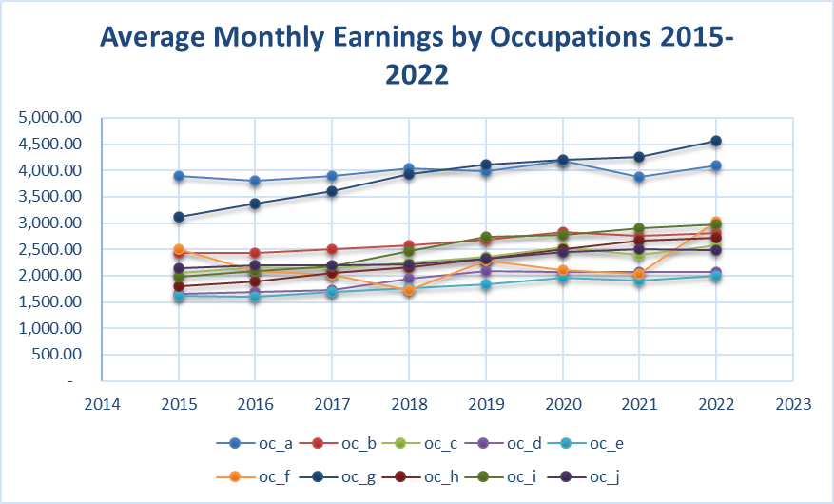
Specific Occupations Analysis: The average monthly earnings for managers ranged from approximately 3,812.85 NIS in 2016 to 4,185.17 NIS in 2020, with a slight decrease in 2021 before rising again in 2022 to 4,091.28 NIS.Professionals also experienced an upward trend in earnings, with values ranging from around 2,426.29 NIS in 2016 to 2,828.04 NIS in 2020, showing a consistent increase over the years.Technicians and Associate Professionalsgroup saw fluctuations in earnings, with the highest average monthly earnings of approximately 2,568.32 NIS in 2022 and the lowest in 2015 at 2,053.00 NIS.Earnings for Clerical Support Works remained relatively stable over the years, with minor fluctuations but no significant upward or downward trends.Similarly, service and sales workers' earnings showed stability, with modest changes across the years but no distinct trend.Skilled Agricultural, Forestry, and Fishery Workersgroup experienced an increase in earnings from around 2,039.41 NIS in 2021 to 3,030.04 NIS in 2022, indicating a notable rise in income levels.Craft and Related Trades Workersalso saw a significant increase in earnings, with values rising from approximately 3,614.06 NIS in 2017 to 4,562.89 NIS in 2022, showcasing a substantial growth in income: Earnings forPlant and Machine Operators, and Assemblers group remained relatively steady over the years, with minor fluctuations but no clear trend of increase or decrease.Elementary Occupationsearnings similarly showed stability with slight variations but no significant overall trend.Average monthly earnings for Armed Forces Occupationsremained relatively constant over the years, with minor fluctuations but no distinct pattern of increase or decrease.

- Labour Force Participation, Labour Force Status, Employment, and Unemployment in Palestine (2015-2022)

The analysis of labour force participation, labour force status, employment, and unemployment in Palestine from 2015 to 2022 reveals a general trend of increasing labour force participation and employment numbers. However, the unemployment rate has also experienced slight fluctuations, indicating the need for continued efforts to address unemployment challenges and promote inclusive economic growth.
The total labour force number in Palestine has shown an increasing trend from 2015 to 2022, rising from 2,743,822 individuals in 2015 to 3,340,663 individuals in 2022. The percentage of individuals aged 15 years and above participating in the labour force has also increased steadily, reaching 44.99% in 2022 compared to 43.97% in 2015.

Within the labour force, the number of individuals actively participating has increased over the years, with 1,206,396 individuals in 2015 rising to 1,502,984 individuals in 2022. Consequently, the percentage of individuals in the labour force has slightly increased from 43.77% in 2015 to 44.99% in 2022.

The number of employed individuals in Palestine has shown fluctuations but an overall increase from 2015 to 2022, reaching 1,135,959 individuals in 2022 compared to 928,866 individuals in 2015. The percentage of employed individuals within the labour force has also increased, with a peak of 77.00% in 2015 and stabilizing around 75% in recent years.

Unemployment numbers have varied across the years, with 277,530 individuals unemployed in 2015 and 367,025 individuals unemployed in 2022. However, the unemployment rate has remained relatively consistent, ranging from 23.00% in 2015 to 26.39% in 2021, showing a slight increase over time.

- Employment by Sex in Palestine (2015-2022)

The analysis of employment by sex in Palestine from 2015 to 2022 highlights a positive trend of increasing employment for both males and females. However, gender disparities persist, with males consistently comprising a larger share of the workforce compared to females. Addressing these gender disparities in employment remains a critical aspect of promoting gender equality and inclusive economic growth.
Employment trends by sex indicates that the number of employed males in Palestine has shown an increasing trend from 2015 to 2022, rising from 771,379 in 2015 to 953,246 in 2022. Similarly, female employment numbers have also increased over the years, from 157,487 in 2015 to 182,713 in 2022. As for the employment distribution by sex: in 2015, males constituted approximately 83% of the total employment, which gradually increased to around 85% by 2021 before slightly decreasing to 84% in 2022. Conversely, females represented around 17% of the total employment in 2015, and this percentage remained relatively stable, ranging from 15% to 16% over the years.
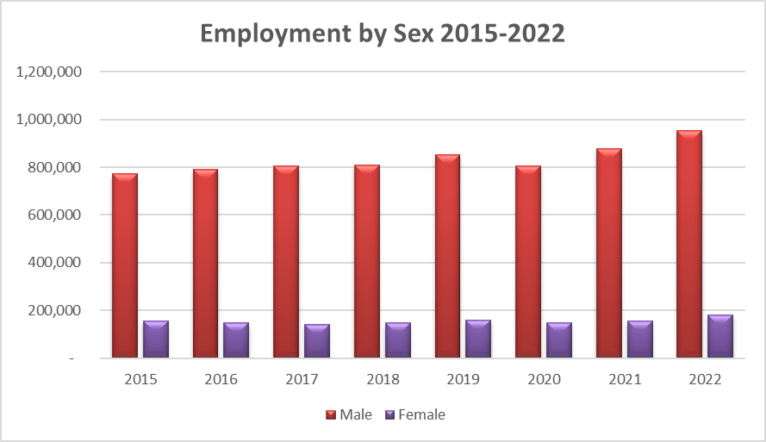
While both male and female employment numbers have increased, there remains a noticeable gender disparity in employment distribution. Males continue to dominate the workforce, occupying a higher proportion of total employment compared to females throughout the years analyzed.

- Employment by Age in Palestine (2015-2022)

Employment trends and distribution by age group reveals varying trends across different age categories. While some age groups have shown consistent growth in employment, others have experienced fluctuations. Overall, there has been a positive trend in employment across most age groups, indicating potential shifts in the workforce dynamics over time.
15-24 Age Group: The number of employed individuals in the 15-24 age group has shown fluctuations over the period, ranging from 152,564 in 2020 to 203,863 in 2022. This age group constituted approximately 16.43% of total employment in 2015 and increased to around 17.95% by 2022.

25-34 Age Group: Employment numbers for individuals aged 25-34 have consistently increased, reaching 372,755 in 2022 from 290,850 in 2015. Individuals aged 25-34 accounted for about 31.33% of total employment in 2015 and grew to approximately 32.84% by 2022.

35-44 Age Group: Similarly, the 35-44 age group has experienced a steady rise in employment, from 231,726 in 2015 to 275,256 in 2022. The 35-44 age group represented around 24.91% of total employment in 2015 and increased to about 24.24% by 2022.

45-54 Age Group: Employment in the 45-54 age group has shown slight fluctuations but remained relatively stable, ranging from 153,687 in 2015 to 184,052 in 2022. Employment in this age group accounted for approximately 16.55% of total employment in 2015 and decreased slightly to around 16.21% by 2022.

55-64 Age Group: Employment numbers for individuals aged 55-64 have increased over the years, from 58,740 in 2015 to 84,648 in 2022. This age group constituted about 6.32% of total employment in 2015 and increased to around 7.45% by 2022.
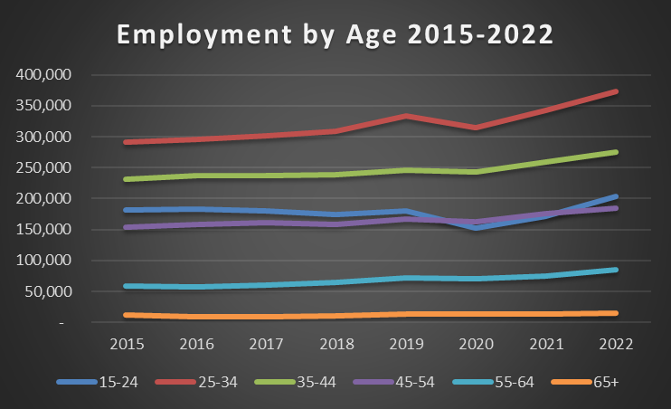
65+ Age Group: Employment in the 65+ age group has also increased, from 12,203 in 2015 to 15,385 in 2022. Individuals aged 65 and above represented around 1.31% of total employment in 2015 and grew to approximately 1.35% by 2022.

- Employment by Education in Palestine (2015-2022)

The total employment in Palestine has shown an overall increasing trend across all education levels, reflecting a diverse and educated workforce contributing to the economy's progress.
The analysis of employment by education in Palestine from 2015 to 2022 highlights positive trends in employment across different education levels. While higher education levels show increased employment, efforts to enhance employment opportunities for individuals with lower education levels remain important for workforce development.
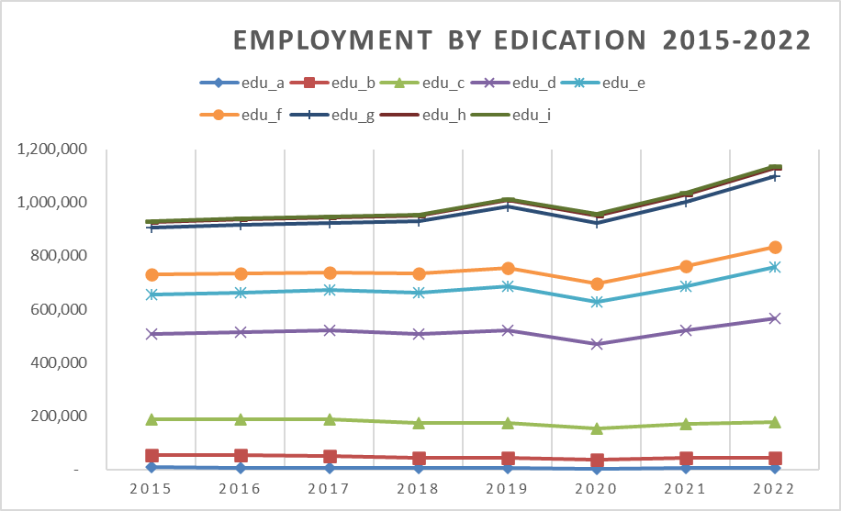
The number of individuals with no schooling ranged from 7,443 (0.801%) in 2015 3,090 (0.323%) in 2020 then it raised up to 4,098 (0.361%) in 2022. This group showed a slight decrease in percentage over the years.
The percentage of individuals with early childhood education remained relatively stable, ranging from 5.039% in 2015 to 3.471% in 2022. Despite minor fluctuations in numbers, this group maintained a consistent presence in the workforce.

The percentage of individuals with primary education ranged from 14.377% in 2015 to 11.754% in 2022. This group constitutes a significant portion of the workforce, showing a slight decrease in percentage over the years.

Individuals with lower secondary education represented a substantial proportion of the workforce, ranging from 34.704% in 2015 to 32.850% in 2020 then to 34.256% in 2022. This group consistently contributed significantly to employment throughout the years.

The percentage of individuals with upper secondary education ranged from 18.797% in 2015 to 16.133% in 2021 then to 16.863% in 2022. This group maintained a considerable presence in the workforce, although showing minor variations in percentage.

Individuals with post-secondary non-tertiary education accounted for a moderate percentage of the workforce, ranging from 6.606% in 2022 to 7.903% in 2015. This group showed relatively stable employment rates over the years.

The percentage of individuals with bachelor's or equivalent level education ranged from 18.797% in 2015 to 24.049% in 2019 then decreased to 23.403% in 2022. This group exhibited a noticeable increase in percentage over the years, indicating a growing presence in the workforce.

Individuals with master's or equivalent level education constituted a smaller portion of the workforce, ranging from the smallest of 2.030% to 2.760% in 2022. This group showed minor fluctuations in percentage, reflecting a relatively stable employment trend.

The percentage of individuals with doctoral or equivalent level education remained consistently low, ranging from 0.374% in 2015 to 0.527% in 2022. This group represents a specialized segment of the workforce with limited presence in overall employment.

4.2 Regression Analysis
Based on regression analysis, the results are presented next.
Model Summary^{b}
Model | R | R Square | Adjusted R Square | Std. Error of the Estimate
1 | 1.000ª | .999 | .998 | 5.61915
a. Predictors: (Constant), Year , GDP IN USD Milions at constant prices 2015, CPI , Unemployment, Gender
b. Dependent Variable: Real Wages in USD

ANOVAª
Model |  | Sum of Squares | df | Mean Square | F | Sig.
1 | Regression | 91912.725 | 5 | 18382.545 | 582.190 | .002^{b}
 | Residual | 63.150 | 2 | 31.575
 | Total | 91975.875 | 7
a. Dependent Variable: Real Wages in USD
b. Predictors: (Constant), Year , GDP IN USD Milions at constant prices 2015, CPI , Unemployment, Gender

Coefficientsª
Model |  | Unstandardized Coefficients |  | Standardized Coefficients | t | Sig. | Collinearity Statistics
 |  | B | Std. Error | Beta |  |  | Tolerance | VIF
1 | (Constant) | -7051772.495 | 859221.643 |  | -8.207 | .015
 | Unemployment | .001 | .000 | .218 | 1.928 | .194 | .027 | 37.201
 | GDP IN USD Milions at constant prices 2015 | -.028 | .006 | -.175 | -4.752 | .042 | .254 | 3.937
 | CPI | -26.331 | 8.862 | -.508 | -2.971 | .097 | .012 | 85.060
 | Gender | .001 | .001 | .362 | 1.904 | .197 | .010 | 105.172
 | Year | .000 | .000 | .919 | 8.207 | .015 | .027 | 36.517
a. Dependent Variable: Real Wages in USD

Excluded Variablesª
Model |  | Beta In | t | Sig. | Partial Correlation | Collinearity Statistics
 |  |  |  |  |  | Tolerance | VIF | Minimum Tolerance
1 | Education | .^{b} | . | . | . | .000 | . | .000
 | Age | -2867.299^{b} | -21.756 | .029 | -.999 | 8.334E-11 | 11999559874.541 | 8.334E-11
 | Activity | 605.216^{b} | .717 | .604 | .583 | 6.361E-10 | 1572080970.086 | 6.361E-10
 | Occoupation | 536.698^{b} | .700 | .611 | .574 | 7.841E-10 | 1275422459.638 | 7.841E-10
 | Sector | -2485.590^{b} | -1.548 | .365 | -.840 | 7.841E-11 | 12753059605.430 | 7.841E-11
a. Dependent Variable: Real Wages in USD
b. Predictors in the Model: (Constant), Year , GDP IN USD Milions at constant prices 2015, CPI , Unemployment, Gender

Collinearity Diagnosticsª
Model | Dimension | Eigenvalue | Condition Index | Variance Proportions
 |  |  |  | (Constant) | Unemployment | GDP IN USD Milions at constant prices 2015 | CPI | Gender | Year
1 | 1 | 5.991 | 1.000 | .00 | .00 | .00 | .00 | .00 | .00
 | 2 | .006 | 30.593 | .00 | .02 | .00 | .00 | .00 | .00
 | 3 | .001 | 63.883 | .00 | .01 | .13 | .00 | .01 | .00
 | 4 | .001 | 74.692 | .00 | .04 | .20 | .00 | .01 | .00
 | 5 | 4.295E-6 | 1181.109 | .00 | .07 | .27 | .81 | .91 | .00
 | 6 | 2.672E-12 | 1497478.422 | 1.00 | .86 | .40 | .19 | .07 | 1.00
a. Dependent Variable: Real Wages in USD

Interpretation of Results
The model includes all specified independent variables without any removals due to tolerance limits.
Model Summary
R: 1.000 - Indicates a perfect correlation between the independent variables and the dependent variable (Real Wages in USD).
R Square: 0.999 - Nearly all (99.9%) of the variance in Real Wages is explained by the model.
Adjusted R Square: 0.998 - Adjusted for the number of predictors, this still shows an almost perfect fit.
Std. Error of the Estimate: 5.61915 - Indicates the average distance that the observed values fall from the regression line.
ANOVA
F-value: 582.190 - A very high value indicating the overall model is statistically significant.
Significance (Sig.): 0.002 - This is well below 0.05, indicating the model is statistically significant.
Coefficients
(Constant): -7051772.495 (p = 0.015) - The intercept term is statistically significant, but its large negative value may not be meaningful without context.
Unemployment: 0.001 (p = 0.194) - Not statistically significant. This suggests that unemployment has a small and not statistically significant impact on Real Wages.
GDP: -0.028 (p = 0.042) - Statistically significant and negative, indicating that as GDP increases, Real Wages decrease, holding other factors constant.
CPI: -26.331 (p = 0.097) - Not statistically significant, suggesting that CPI does not have a significant impact on Real Wages.
Gender: 0.001 (p = 0.197) - Not statistically significant, indicating gender does not significantly affect Real Wages.
Year: 0.000 (p = 0.015) - Statistically significant and very small in magnitude, indicating a small but significant positive effect of Year on Real Wages.
Collinearity Statistics
Tolerance and VIF: The VIF values are particularly high for CPI (85.060) and Gender (105.172), indicating severe multicollinearity. This can distort the regression coefficients and make them unreliable.
Collinearity Diagnostics
Condition Index: The condition indices suggest severe multicollinearity, especially in dimensions 5 and 6 (1181.109 and 1497478.422). This confirms the multicollinearity issue.
Residuals Statistics
Predicted Values and Residuals: The residuals are relatively small, suggesting a good fit of the model. The standard deviation of the residuals is 3.00356, indicating the model's predictions are close to the observed values.

4.3 Discussion of Key Findings
Multicollinearity: The model exhibits significant multicollinearity, especially with CPI and Gender. This can lead to unreliable and unstable estimates of regression coefficients. Addressing this issue is crucial. Consider using techniques such as Ridge Regression, Principal Component Analysis (PCA), or removing/combining collinear variables to mitigate multicollinearity.
Model Significance: While the overall model is statistically significant, some individual predictors (Unemployment, CPI, Gender) are not. Reevaluate the model to ensure that only significant predictors are included. Stepwise regression or regularization methods could help in selecting the most relevant variables.
Sample Size: The model is based on a small sample size (N=8), which may not provide reliable estimates and could lead to overfitting. Increasing the sample size would improve the robustness and generalizability of the results.
Variable Impact: The negative relationship between GDP and Real Wages is counterintuitive and warrants further investigation. This could be due to multicollinearity or other model specification issues.
Residual Analysis: The residuals are small and normally distributed, indicating a good fit. However, examining residual plots for any patterns or heteroscedasticity can further validate the model assumptions.
Intercept Term: The large negative intercept may not be meaningful in practical terms. Interpret it with caution, considering the context and the range of the independent variables.

Chapter 5: Conclusions and Recommendations

6.1 Summary of Findings
In summary, while the model explains nearly all the variance in Real Wages, the presence of severe multicollinearity and a small sample size suggest the need for careful model refinement and validation. Addressing these issues would lead to more reliable and interpretable results.

References
Khalidi, R. (2017). What Is the “Palestinian Economy”?. In: Gürbey, G., Hofmann, S., Ibrahim Seyder, F. (eds) Between State and Non-State. Palgrave Macmillan, New York.
Kanafani, N. (Ed.). (2023). Economic Monitor: First Quarter 2023 (Issue 73). Palestine Economic Policy Research Institute (MAS), Palestinian Central Bureau of Statistics (PCBS), Palestine Monetary Authority (PMA), & Palestine Capital Market Authority (PCMA).
World Bank. (2022). Palestinian Labor Market Outcomes, Dynamics, and Policies.
Becker, G. S. (1964). *Human Capital: A Theoretical and Empirical Analysis, with Special Reference to Education*. University of Chicago Press.
Mincer, J. (1974). *Schooling, Experience, and Earnings*. Columbia University Press.
Doeringer, P. B., & Piore, M. J. (1971). *Internal Labor Markets and Manpower Analysis*. Lexington Books.
Piore, M. J. (1972). *Notes for a Theory of Labor Market Stratification*. MIT Department of Economics.
Blau, F. D., & Kahn, L. M. (2000). Gender Differences in Pay. *Journal of Economic Perspectives, 14*(4), 75-99.
Goldin, C. (2014). A Grand Gender Convergence: Its Last Chapter. *American Economic Review, 104*(4), 1091-1119.
Mankiw, N. G. (2009). *Principles of Economics*. Cengage Learning.
Solow, R. M. (1956). "A Contribution to the Theory of Economic Growth." *Quarterly Journal of
Economics*, 70(1), 65-94.
World Bank. (2018). *Economic Monitoring Report to the Ad Hoc Liaison Committee*. World Bank
Group.
Friedman, M. (1968). "The Role of Monetary Policy." *American Economic Review*, 58(1), 1-17.
Phillips, A. W. (1958). "The Relationship between Unemployment and the Rate of Change of Money Wage Rates in the United Kingdom 1861-1957." *Economica*, 25(100), 283-299.
Palestinian Central Bureau of Statistics. (2023). *Consumer Price Index*. https://www.pcbs.gov.ps/postar.aspx?lang=ar&ItemID=4681
Palestinian Central Bureau of Statistics, 2023. Labour Force Survey: (July- September 2023) Round, (Q3/2023). "Press Report Labour Force Survey. Ramallah - Palestine.
Adnan, W. (2014). Examining Industry Wage Differentials in the Palestinian Territories. Review of Middle East Economics and Finance, 123-150.
Al Botmeh, S., & Sadeq, T. (2020). Impact of the Covid-19 pandemic on the labour market in the occupied Palestinian territory: A forecasting model assessment. Bierut: International Labour Organization.
Al-Falah, B. (2014). Evaluation of Employers' Compliance with the Minimum Wages Regulations in the West Bank. Ramallah: Palestine Economic Policy Research Institute (MAS).
Ayyash, M., & Kun, S. (2019). Multilevel Analysis of Wage Inequality in Palestine. Statistika: Statistics and Economy Journal, 317-335.
Coulibaly, K., Ma, J., & Qassis, H. (2023). PALESTINIAN LABOR MARKET OUTCOMES, DYNAMICS, AND POLICIES. Washington, D.C: INTERNATIONAL MONETARY FUND.
Daoud, Y., & Shanti, R. (2016). Private–Public Sector Employment Choice and Wage Differentials in Palestine: A Gender Perspective. Women, Work and Welfare in the Middle East and North Africa, 383-408.
Fallah, B., & Daoud, Y. (2015). Wage differentials and economic restrictions: Evidence from the Occupied Palestinian Territories. The Economics of Peace and Security Journal, 13-22.
Hiaari, S. (2020). An Analysis of the Public-Private Wage Differential in the Palestinian Labor Market. Defence and Peace Economics, 289–314.
International Monetary Fund. (1999). The Palestinian Labor Market Since Oslo. In I. M. Fund, West Bank and Gaza Strip - Economic Developments in the Five Years Since Oslo (pp. 47-57). Washington, D.C.: International Monetary Fund.
Mataria, A. (2007). Wage Differentials in a Fast-Changing Environment: A Sectoral Analysis. Ramallah: Palestine Economic Policy Research Institute (MAS).
MORRAR, N. (2022). Gender Differences In Labour Market: A Case Study Of The Palestinian Economy. Webology, 2984-3005.
Naqib, F. M. (2006). Wages and productivity in the Palestinian Industrial sector (1996-2004). Ramallah: Palestine Economic Policy Research Institute (MAS).
Yousef, D., & Belal, F. (2014, 06 30). WAGE DIFFERENTIAL BETWEEN URBAN AND RURAL PALESTINE: THE SHADOW OF PALESTINIAN- ISRAELI CONFLICT. Working Paper Series. Dokki, Giza, Egypt: The Economic Research Forum.
مساليا, م., كابيلي, ك., &عامر, و. (2010). الآثار المحتملة لتبني السلطة الوطنية الفلسطينية لسياسة الحد الأدنى للأجور.رام الله: معهد ابحاث السياسات الاقتصادية الفلسطيني (ماس).

